Software Prerequisite Setup - Manual

Mahaseel Mobile Application Development

1. Table of Contents

**1[. Document Purpose](https://word-edit.officeapps.live.com/we/wordeditorframe.aspx?ui=en%2DUS&rs=en%2DUS&hid=35B84F9F%2D70F5%2DA000%2DC95F%2D7AFBA3C3A6AE&WOPISrc=https%3A%2F%2F4iappssolutions%2Dmy%2Esharepoint%2Ecom%2Fpersonal%2Fbalaji%5Fmanickam%5F4iapps%5Fcom%2F%5Fvti%5Fbin%2Fwopi%2Eashx%2Ffiles%2Fa33a42e4f7994fa0a812207d8d9af354&&&wdenableroaming=1&wdfr=1&wdodb=1&wdOrigin=AppModeSwitch&wdredirectionreason=Unified%5FSingleFlush&wdModeSwitchTime=1588757984361&wdPreviousSession=3f165b7a-0515-4307-87ae-f27632bb2f11&wdPid=2C078E63&pdcn=pdc1a2e" \l "_Toc31192734)**

**2[. Environment Setup](https://word-edit.officeapps.live.com/we/wordeditorframe.aspx?ui=en%2DUS&rs=en%2DUS&hid=35B84F9F%2D70F5%2DA000%2DC95F%2D7AFBA3C3A6AE&WOPISrc=https%3A%2F%2F4iappssolutions%2Dmy%2Esharepoint%2Ecom%2Fpersonal%2Fbalaji%5Fmanickam%5F4iapps%5Fcom%2F%5Fvti%5Fbin%2Fwopi%2Eashx%2Ffiles%2Fa33a42e4f7994fa0a812207d8d9af354&&&wdenableroaming=1&wdfr=1&wdodb=1&wdOrigin=AppModeSwitch&wdredirectionreason=Unified%5FSingleFlush&wdModeSwitchTime=1588757984361&wdPreviousSession=3f165b7a-0515-4307-87ae-f27632bb2f11&wdPid=2C078E63&pdcn=pdc1a2e" \l "_Toc31192735)**

**2a) Node Installation guide**

**2b) Oracle instant client library path setup**

1. DOCUMENT PURPOSE

The purpose of this document is to outline the software prerequisites for setting up development and production environments.

1. ENVIRONMENT SETUP

A) NodeJs Installation guide

The latest version of Node.js can be installed from node source repository. Follow the steps below to install the Node.js on your Ubuntu.

**Step 1:** Add Node.js PPA to the system.

***curl -sL https://deb.nodesource.com/setup\_10.x | sudo -E bash –***

**Note:** Here, we are installing node.js version 10, if you want to install version 14, you can replace setup\_10.x with setup\_14.x.

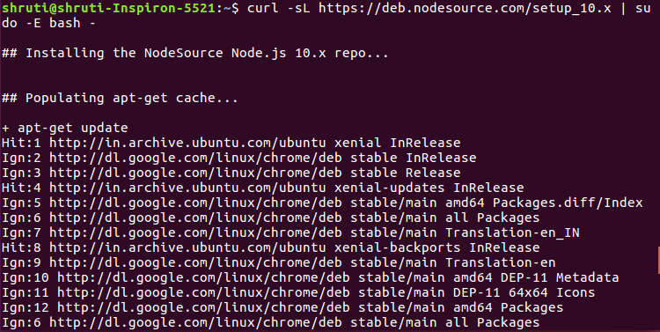

**Step 2:** To Install Node.js and NPM to your Ubuntu machine, use the command given below:

***sudo yum install nodejs***

**Step 3:** Once installed, verify it by checking the installed version using the following command:

***node -v*** *or* ***node –version***

***npm -v*** *or* ***npm –version***

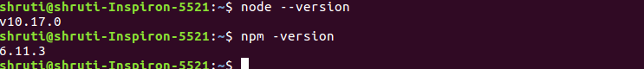

B) Oracle instant client library path setup

The purpose of oracle instant client library is to make connection oracle database on node environment.

**Step 1:** Download the instant client library zip file from the below link.

**[Download - Oracle Instant Client Library zip file](https://download.oracle.com/otn_software/linux/instantclient/19600/instantclient-basic-linux.x64-19.6.0.0.0dbru.zip)**

**Step 2:** Place zip file into /home/Desktop/software directory and unzip using following command.

**unzip instantclient-basic-linux.x64-19.3.0.0.0dbru.zip**

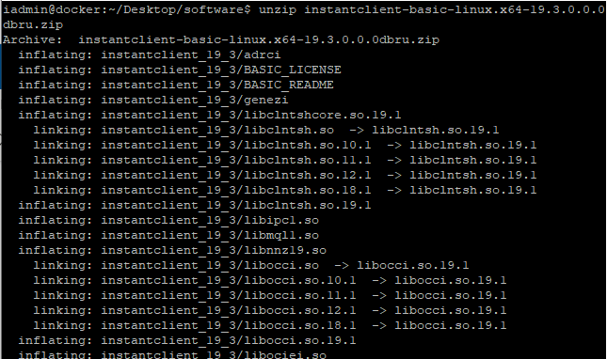

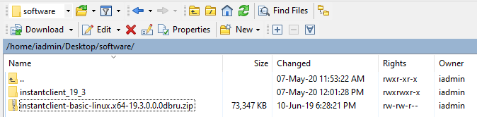

**Step 3:** Make directory into /usr/lib/oracle/ and then move instantclient\_19\_3 folder into /usr/lib/oracle/

**mv instantclient\_19\_3 /usr/lib/oracle/**

**Step 4:** Put the following commands for setting lib path

**sudo sh -c "echo /usr/lib/oracle/instantclient\_19\_3 > /etc/ld.so.conf.d/oracle-instantclient.conf"**

**sudo ldconfig**

**export LD\_LIBRARY\_PATH=/usr/lib/oracle/instantclient\_19\_3:$LD\_LIBRARY\_PATH**

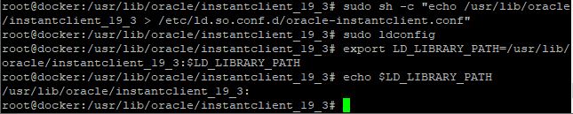

**Step 5:** Go to root directory in terminal and put the following commands to set path.  
  
For instance, it is in /home/applmgr  
  
**echo 'export LD\_LIBRARY\_PATH=/usr/lib/oracle/instantclient\_19\_3:$LD\_LIBRARY\_PATH' >> ~/.bashrc**  
  
**echo 'export PATH=$LD\_LIBRARY\_PATH:$PATH' >> ~/.bashrc**Note: You can verify this. Close and open terminal again, then type command “**echo $LD\_LIBRARY\_PATH”**. It has to show the path.

